In ASP.Net Mvc I have performed CRUD Operation. All the screenshot has been attached.

1. **Search Customer Page**

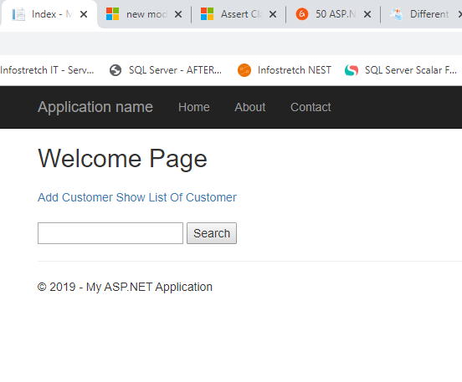

**2. Insert Detail Page**

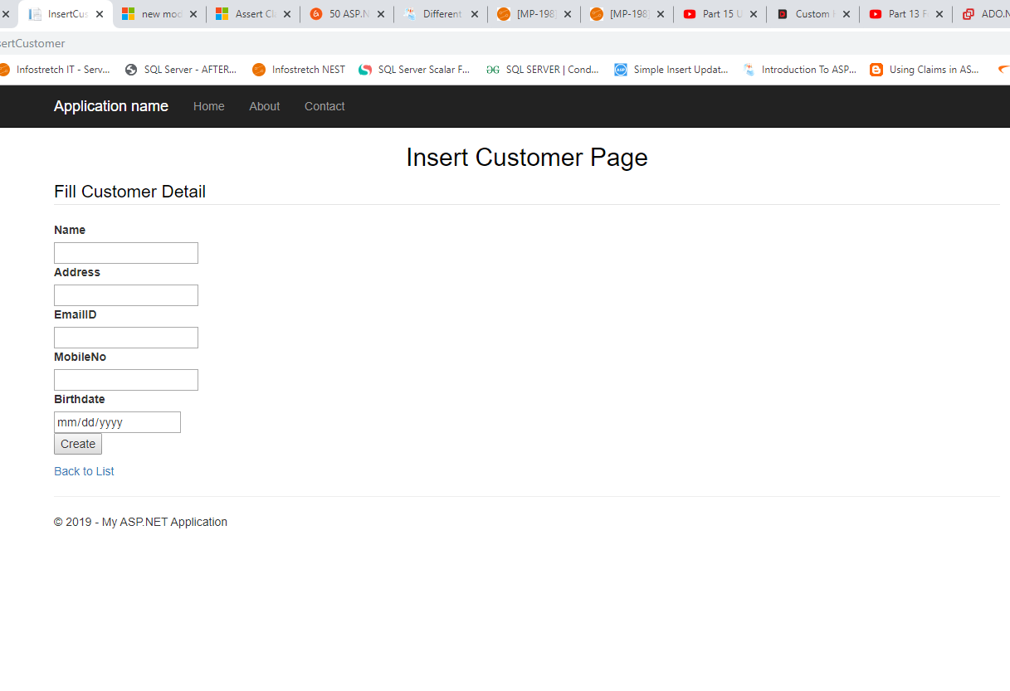

**3. Edit Customer Detail**

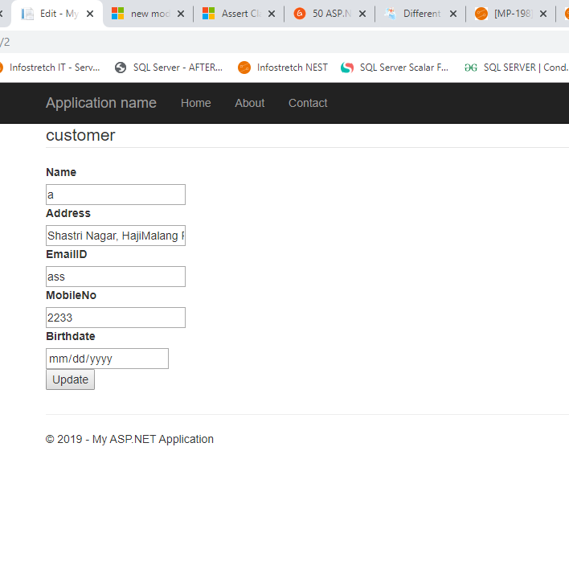

**4. Show All Customer Detail**

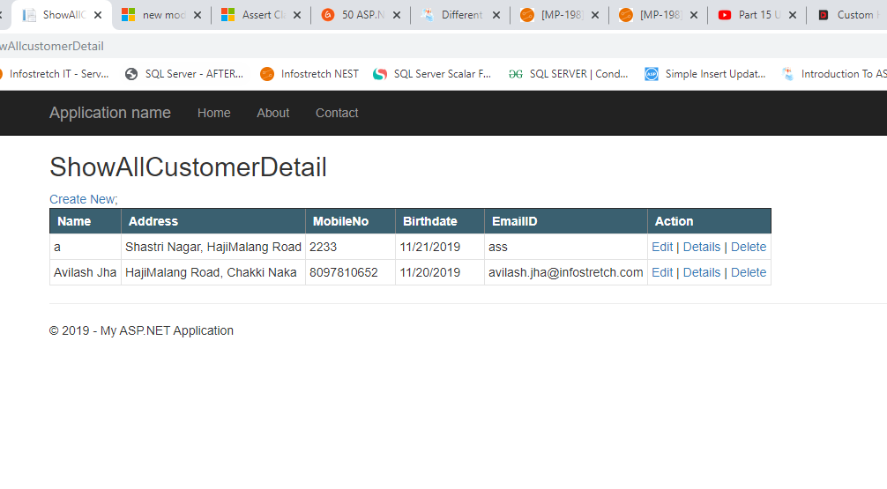

**5. Show Customer Detail by CustomerId**

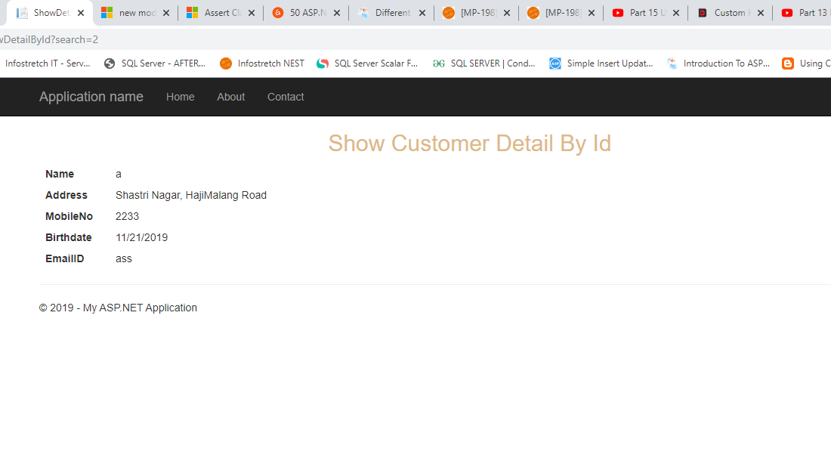

**6.** **Delete Customer Detail**

